Green Lake Association Meeting minutes 10/18/2022
Attendees: Guest: Ben Larson, Lake Member Ben Elfel, LID rep.
Board - Jason Houle, President
Michelle Carlson, Secretary
Travis Lamotte- VP
Troy Ashton- Treasurer
Bob Milam-

AGENDA
Call to Order:
Introduction of Ben Elfelt - New LID Administrator, Ben Elfel.

Review/approval of last meeting minutes:
  - Motion to approve last month’s meeting minutes
  - Motion: Jason
  - Second: Michelle

Treasurer’s Report and Association bills to be paid:
Money in Checking: $14,039.25
Money in Money Market Account: $

- Overview on payments to Band and others.-Band was paid and good feedback, Travis will reach out to start talking 2023 dates.
- Get deposit detail to Troy for many deposits made between 5/18/2022 thru 8/19/2022. I have attached the specific deposits that are in the bank account but no logged into QuickBooks.
- Move Stripe account over to Troy, or create a new one.
- Change Venmo over to Troy or create a new one. Travis will transfer Venmo to Troy.
- Either cancel Paypal payment option or create a new one.- Jason, looking into Paypal and if we can remove or need to keep it. What is it linked to? No payments received so Paypal will be canceled.
- Maturing CDs, other CDs and Maturities
- LID Check, Reimbursement for LID for treatment, Bob will take care of getting the reimbursement. Jason to get invoice to Bob. $money received from LID and deposited.
- Reimbursement to Jason-Jason to send invoices to Troy for reimbursement.
- City Dock Grant Funds-Jason doing follow up. Possibly, $1K payment for landscaping, Jason looking into with the city.
- Can recycling update, $450 most recently deposited, $2000K a year.

New Business:
- LID Opening- Monica moved into a new Watershed role, opening at the LID, wanting to be involved in identifying who is appointed to keep the relationship strong.
- Mid Season newsletter for dues? President letter and recap of season, Travis, Music on the Water, Troy, Finance, Jason, President letter.
- Thank you dinner to supporting members-Jason to put together a date and board send a list of participants.
- Boat Storage, cut check, storage rented for a year / Winterization / Batteries / Overview.
- Treatment Overview of Milfoil and CLP- treatment went well and did good work, we are out of chemical so will need to buy chemical for next season.
- Purple Loosestrife Overview- Going to treat by Lake management in the Spring 2023.
- Carp Fence removal- fence was removed.
- Website Overview and Changes for 2023? Everyone should go onto the website and look for updates and changes.
- Board meetings open to all active members- put meetings on website and RSVP 7 days prior to accommodate the venue and if nothing then closed door.
- Music on the water - recap and discussions for 2023, Travis get he band confirmed for next year 2023.
- Director and Officer insurance. Jason to put together a plan- DNO insurance.
- Overview on new Board Members moving forward, document the dates on the board with the photos. Jason to edit the website with dates of service and positions.
- Jim Revel donating the barge – discussion of what to do with it, and a thank you post.
- Overview of where we are at on water level, see below chart
- Jason to give Troy his email access to treasury

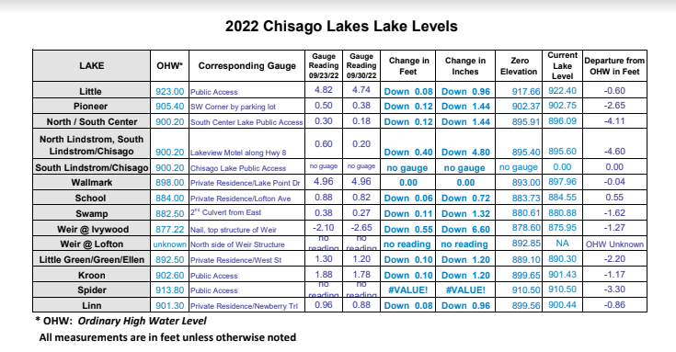

Open Forum:
- Ben, phragmites checks by LID.
- LID Rep, replacement for LID role, Monica. November 7th meeting. December appointment to be made.

Unfinished Business:
- Board Member terms / start and finish, documented. Should be put on website? Jason to edit website to dates of position.
Jason Houle – March 11th 2020 VP Vote in
Jason Houle – March 10th - Voted President
Travis LaMotte – May 11th 2021 Voted VP
Michelle Carlson- May 25th 2021 Voted Secretary
Troy Ashton – June 7th 2022

Meeting Adjourned:
  - Motion:
  - Second:

Next Meeting: TBD

